
Bash and Shell
- vi python_files.sh

Why:
- To create or edit a shell or Python script.
- vi is a standard terminal-based text editor in Linux.

What it does:
- Opens a file named python_files.sh in the vi text editor.
- If the file doesn’t exist, it creates a new empty file.

- chmod 700 python_files.sh

Why you use it:
- To make a script executable by the owner.
- Without execute permission, you cannot run the script using ./python_files.sh.

What it does:
- Changes the permissions of the file python_files.sh.

- ./python_files.sh

Why you use it:
- To run your shell script after making it executable (chmod 700 python_files.sh)

What it does:
- Executes the script python_files.sh in the current directory.
- The ./ tells the shell: “run this file here.”
- Using a variable

teams=7 → declares a variable in Bash.
echo "Total IPL teams are $teams" → prints the variable’s value.

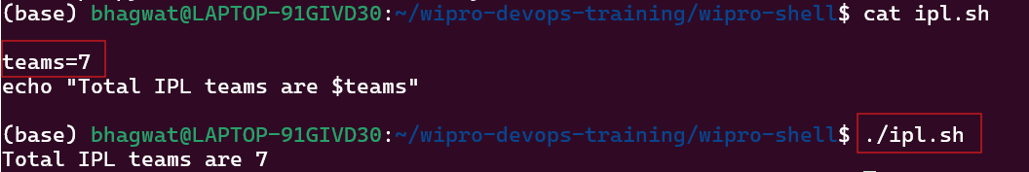

- Created files inside file.sh

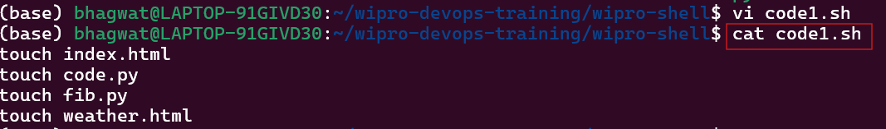

- Multiple directories created

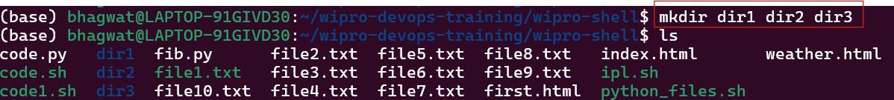

- Created files inside script and executed it

Why we use it
- To create configuration files
- To generate scripts automatically

What it does (in simple words)
- Writes multiple lines of text (code)
- Directly into a file called filename
- Without opening an editor like vi or nano

